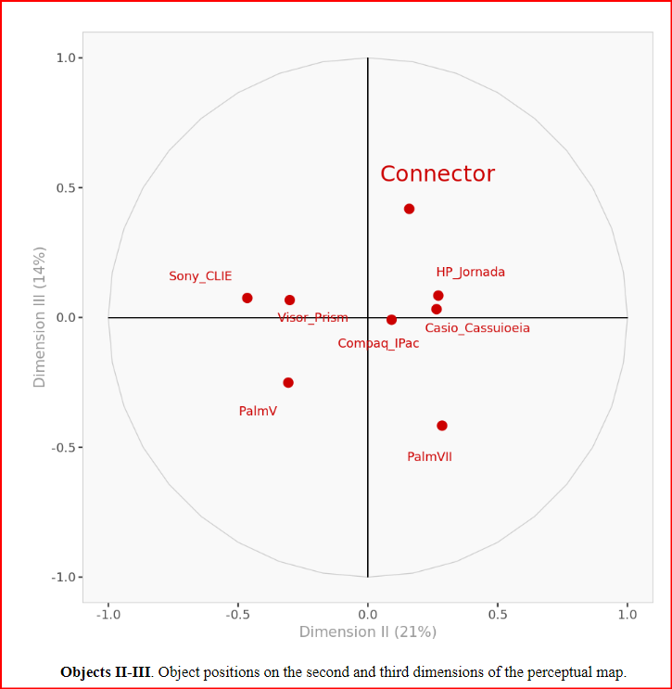

***POSITIONING THE CONNECTOR 2001 CASE STUDY ANALYSIS***

*Supervisor: Zhangchen Hu*

*Department: ISDS*

*By:*

*Evan Duran*

*Jeevan Gowda Hemanth Kumar*

*Adrian Vasquez*

*Nanditha Kolakaluru*

*Thanvitha Kolluri*

**INTRODUCTION**

The Connector is a newly created handheld gadget from Netlink Inc. that combines wireless technology with PDA features that is soon to be released. Conglomerate Inc., a significant wireless provider in the US, and a domestic PC manufacturer have partnered together to form Netlink Inc. Conglomerate entered this partnership to participate in a rapidly expanding market and to bring new users to its cellular services. The Connector 10 L will be the first significant product that Netlink would bring to market since the company's founding. The Connector will compete in the market with other PDA’s and Pocket PC’s from companies like Compaq and Palm, *Figure 1* below highlights a sample of some of the markets competition. Although Netlink's management is optimistic about Connector, they are still unsure about the ideal positioning and market for their new product.

*Figure 1: Sample Of Pda Market (left to right: Compaq IPAQ, Casio CASSIOPEIA, HP PocketPC)*

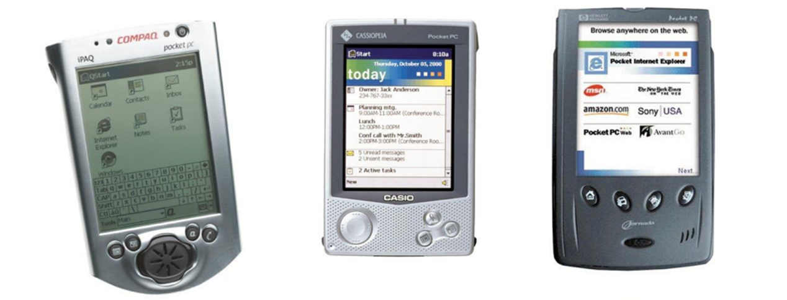

**BACKGROUND**

The PDA market was highly competitive with firms constantly trying to differentiate themselves from one another through technological innovation. Companies like Palm and Compaq vie for market share by predicting and influencing the specific type of wireless technology that consumers will demand. Additionally telecommunication firms like AT&T compete in this space through connectivity and networking offerings. The Palm VII and other PDAs with comparable features are either on the market or in development, contrary to Netlink's claim that Connector will be the first handheld device to allow for genuinely wireless transfer of voice and data. The first handheld with an inbuilt wifi modem was the Palm VII. Although many PDAs, such as the Palm III and V series, allow users to read offline email while traveling after downloading these messages from their home or office PC, models with wireless modems enable users to access mail using the internet from virtually anywhere. Other wireless handheld devices and accessories have started to become available since the Palm VII was first released, such the RIM Blackberry and the OmniSky Minstrel modem for the Palm V. However, there are some significant limits to this kind of wireless connectivity at the moment. Only a few wireless applications are currently available (you can't just go to any website and expect to be able to view it; you're limited to viewing only a few bundled sites), the connection is frequently sluggish, and the cost of the service is high because monthly service plans are required. Given these drawbacks, it appears that most PDA users are reluctant to switch to wireless because they rarely require constant connectivity.

With the release of its Connector, Netlink expects wireless connectivity will transcend nerd appeal. The Connector 10L model is expected to have the following characteristics:

* True wireless access, or the ability to instantly send and receive voice and data at any time (for usage as a cell phone, e-mail, etc.).
* Voice-recognition software and voice-recording equipment:
* Monochrome, backlit monitor; for $20, a clip-on that fastens to the monitor and enlarges the display is available.

**DATA DESCRIPTION**

To better understand how the Connector stacks up against its competitors in space, a survey of 50 potential customers was conducted. Participants in the study were asked to rate eight distinct handheld devices (PDAs and PocketPCs). This competitive set included high-end versions of the most well-liked PDA devices as well as a prototype of the Connector 10L. Electronic organizers and PocketPCs, the two main categories of handheld devices, are represented. Pocket PCs include the Compaq Ipaq, HP Jornada, and Casio Cassiopeia. These devices run Microsoft's Windows for PocketPC, just like the majority of PocketPCs, and include a plethora of applications that are essentially scaled-down versions of the Microsoft Office suite. Their benefits include increased memory capacity, improved PDA and PC synchronization, and a wider selection of add-on accessories (such as webcams and digital cameras). The study's sample frame consisted of Connector's target market, which is defined as mobile phone users who require instantaneous data transfer. To determine whether a person was a good fit for the target market, phone interviews were done at random.

Fifty participants in all were paid to take part in the study. Furthermore, ten study participants were chosen by lottery to receive the PDA that had earned the highest evaluation possible. All participants were exposed to all of the handhelds and the advertisements for them throughout the study because Netlink did not anticipate that all potential customers would be sufficiently knowledgeable about the eight different products of the study (including the prototype-status only Connector).

The results of the survey can be seen below accompanied with a description of the surveyed attributes.

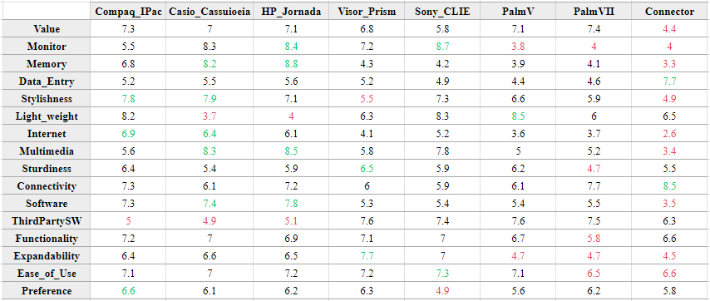

Attribute Description

Price Value: Cost to benefit assessment

Monitor Quality: Size, resolution, readability of the monitor, etc. Color (color screens are significantly more expensive than

monochrome)

Memory: Determines the maximum file size of the address list, etc. PalmOS based applications are designed to claim

comparatively little memory.

Data Entry: Ease of data entry via onscreen keyboard entry, additional keyboards, voice recording and recognition

Stylishness: Attractiveness of the exterior

Light Weight: Ease of carrying the handheld around

Internet Capabilities: E-mail, web access, web clippings

Multimedia: Quality of sound and picture display (MP3 playback, digital camera, games)

Sturdiness: Does the device appear fragile or robust?

Connectivity: Reach of and to user in data/voice

Software: Functionality, usefulness, and variety of software installed on the

Third Party Support: Extent of availability of useful third party add-on applications

Functionality: Useful device or incomplete gadget

Expandability: Ability to turn handheld into a cell phone, digital camera, MP3 player, etc. through modules (e.g., the

Visor's "Springboard" expansion slot allows for various peripheral hardware)

Ease Of Use: Jog dial or simple buttons, easy manual, self-explanatory features, etc.

Preference: Average preference values of the participants

**ANALYSES**

| **Question 1:** Using the data in Exhibit 1 and the associated perceptual mapping software, describe the two (or, if applicable, three) dimensions underlying the perceptual maps that you generated. Based on these maps, how do people in the market perceive the Connector 10L compared with its competitors? |
| --- |

For this Positioning analysis, we created a positioning map to better understand where the Connector 10L and its competitors stack up amongst a variety of important consumer attributes. To create this perceptual map we conducted a Principal Component Analysis, to create the necessary dimensions which helps us group important attributes and better visualize the competitive landscape. We chose to use 3 dimensions in this analysis because 3 dimensions accounted for 80% of the cumulative variance found within the data set. The breakdown of variance by dimension can be seen in *Figure 2* below.

*Figure 2: Variance explained by each dimension*

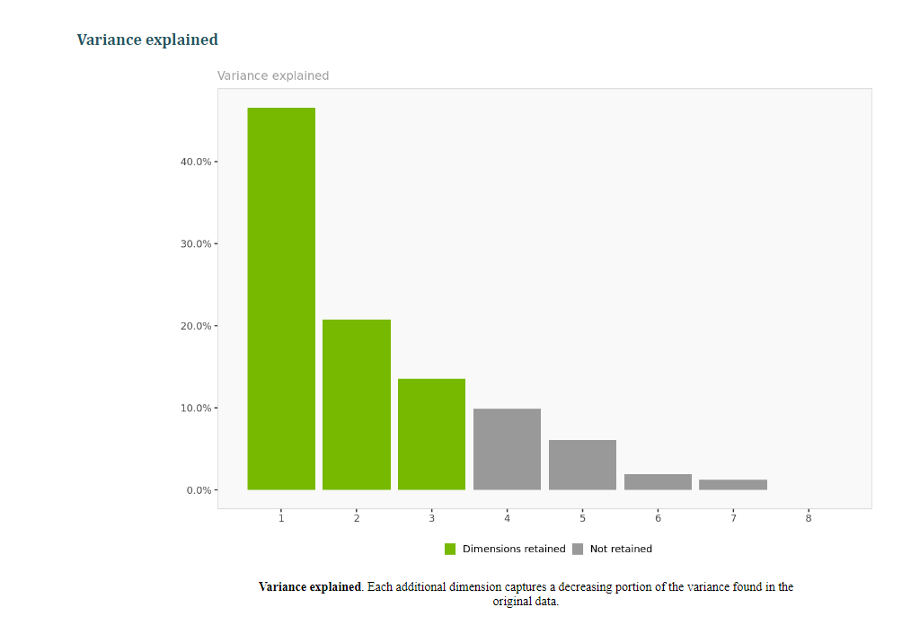

These dimensions or principal components are a linear combination of original variables in a dataset that captures the most significant variation. The weights used for each dimension can be seen in *Figure 3* below.

*Figure 3: Weights of Attributes used to Create Dimensions.*

|  | **Dimension I** | **Dimension II** | **Dimension III** |
| --- | --- | --- | --- |
| **Value** | -0.343 | 0.15 | -0.927 |
| **Monitor** | -0.809 | -0.2 | 0.553 |
| **Memory** | -0.722 | 0.684 | 0.103 |
| **Data_Entry** | 0.211 | 0.317 | 0.924 |
| **Stylishness** | -0.917 | 0.086 | -0.39 |
| **Light_weight** | 0.283 | -0.927 | -0.248 |
| **Internet** | -0.947 | 0.321 | -0.025 |
| **Multimedia** | -0.996 | 0.061 | -0.063 |
| **Sturdiness** | -0.368 | -0.813 | 0.451 |
| **Connectivity** | 0.469 | 0.807 | 0.359 |
| **Software** | -0.789 | 0.475 | -0.39 |
| **ThirdPartySW** | 0.429 | -0.745 | -0.51 |
| **Functionality** | -0.524 | -0.422 | 0.74 |
| **Expandability** | -0.761 | -0.489 | 0.426 |
| **Ease_of_Use** | -0.636 | -0.743 | 0.207 |
| **Preference** | -0.195 | 0.952 | -0.237 |

Dimension one has a strong negative association with the attributes *multimedia, internet, stylishness* and *Monitor*. We can say that this component measures a product's design and use as a media player.

Dimension two has a strong positive association with the attributes *preference* and *connectivity*. This dimension can be seen as a measure of overall consumer satisfaction.

Dimension three has a positive association with the attributes *Data Entry* and *Functionality*. This dimension can be seen as a measure of the product's utility and useability.

Using these dimensions we can plot each of the products in a three dimensional space, showing us a true visualization of where each product stacks up amongst its competitors. The coordinates for each of the products along our three dimensions can be seen in *Figure 4* below. The Connector had a fairly mixed performance amongst the consumer attributes. Connectors Dimension one coordinate of 0.779, the highest amongst all products compared, shows us that consumers in our study did not find the Connector to be very stylish or as a suitable media player when compared to the competition. Connector came in with a value of 0.159 for dimension 2 placing it within the middle of the competitors in this dimension meaning that the consumers found the Connector to be relatively preferable with good connectivity. In Dimension 3 the Connector came in with 0.418 which was the highest amongst all competitors. Consumers reported that Connector had strong Data entry capabilities.

*Figure 4: Coordinates for each Device in Dimensions I-III*

|  | **Dimension I** | **Dimension II** | **Dimension III** |
| --- | --- | --- | --- |
| **Compaq_IPac** | -0.321 | 0.091 | -0.009 |
| **Casio_Cassuioeia** | -0.486 | 0.264 | 0.032 |
| **HP_Jornada** | -0.469 | 0.271 | 0.084 |
| **Visor_Prism** | -0.053 | -0.301 | 0.067 |
| **Sony_CLIE** | -0.158 | -0.465 | 0.075 |
| **PalmV** | 0.221 | -0.307 | -0.251 |
| **PalmVII** | 0.487 | 0.286 | -0.417 |
| **Connector** | 0.779 | 0.159 | 0.418 |

From the perceptual mapping Connector 10L was largely in a class of its own. In dimension three there were only two other competitors, the HP Jomadtham, and the Casio Casio Cassuioeia that shared similarities based on *Data_Entry* and *Functionality.* This tells us that Connector 10L is a relatively unique product and customers differentiate the Connector from the other products in the market. This differentiation could be advantageous as management can leverage that as an advantage and position the Connector as an innovative product that does so much more than other devices on the market. However it could also be seen as a disadvantage as customers could see the Connector as a specialty product that doesn't appeal to the masses. That is why it is important for Netlink to position itself in a way to leverage its ability to combine voice and data and PDA features into a single device.

*Figure 5: Perceptual map of Connector with competitors, comparing in 1st & 2nd dimensions*

~~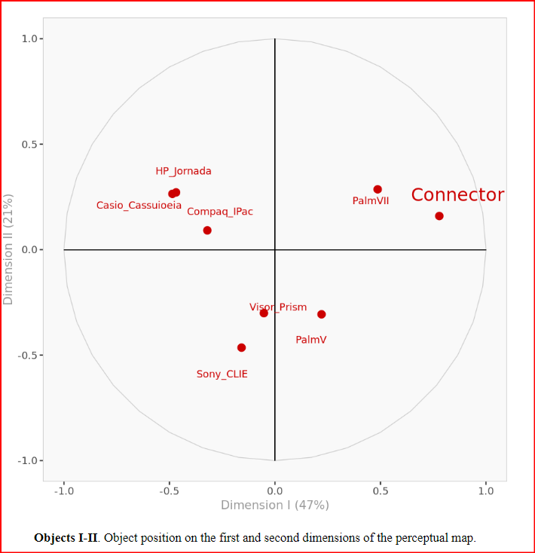~~

*Figure 6: Perceptual map of Connector with competitors, comparing in 1st & 3rd dimensions*

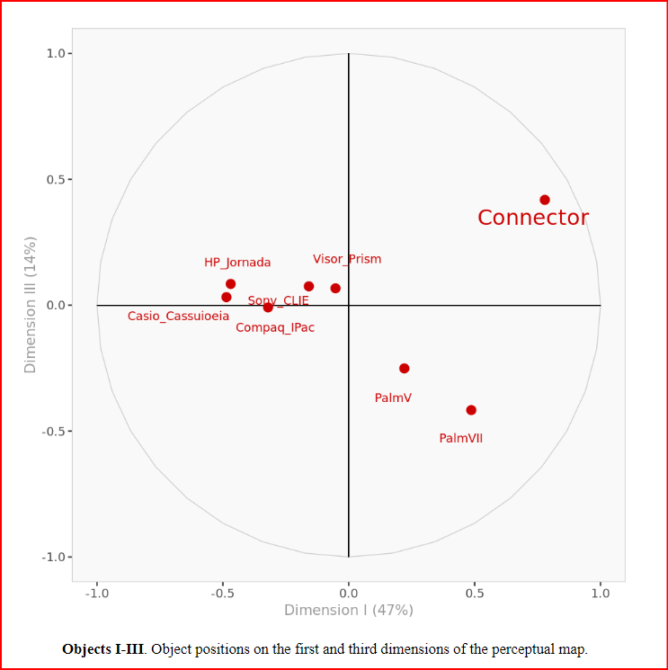

*Figure 7: Perceptual map of Connector with competitors, comparing in 2nd & 3rd dimensions*

| **Question 2**: Netlink intends to promote the Connector as a sleek handheld device for people always on the go, which is a better valued alternative to other wireless PDAs in the market, as it supposedly also relieves its owner of the need for an additional cellular phone. Is this a credible claim to the people who participated in the study? |
| --- |

*Figure 9* below shows the Connectors scores in all of the relevant attributes listed within the marketing statement, along with the sample means and standard deviations for those attributes across our sample of devices. Additionally we conducted a simple analysis to determine how significant the scores the Connector received were relative to the rest of the devices sampled. Based on survey respondents, the claim that the Connector is a sleek handheld device that is a good value for people on the go would not be a credible claim as it fails to deliver on two out of the four claims. Repondants found that the Connector was significantly less stylish and a worse value compared to the competition. In terms of its ability to be taken on the go, consumers found the Connector to be about as lightweight as the other products compared. Where the Connector really shined was in the category of connectivity. The Connector had the highest overall score for connectivity of 8.5 which was significantly higher than the mean of 6.85.

*Figure 9: Marketing statement attribute analysis*

|  | **Connector** | **Mean** | **Stdev** | **Z** | **p value** |
| --- | --- | --- | --- | --- | --- |
| **Stylishness** | 4.9 | 6.625 | 1.099 | -1.569608735 | 0.05825308253 |
| **Light_weight** | 6.5 | 6.438 | 1.87 | 0.03315508021 | 0.4867754596 |
| **Value** | 4.4 | 6.613 | 1.0218 | -2.165785868 | 0.01516377687 |
| **Connectivity** | 8.5 | 6.85 | 0.9651 | 1.709667392 | 0.04366369792 |

| **Question 3:** Rerun the analysis in question 1, this time including the customer preference data from Exhibit 2. From the resulting (joint-space) map, which attributes are most important in influencing the preferences for these handheld devices? |
| --- |

*Stylishness, internet, software, memory, value, multimedia, data_entry, preference,* and connectivity appeared to be the attributes that were the most influential of preference for the respondants.

| How heterogeneous are the preferences of the study participants? |
| --- |

The participants in the study represented a fairly diverse set of preferences about the PDA products surveyed with average preferences ranging from 4.86-6.60

| How many meaningful segments are there? |
| --- |

There were three distinct segments amongst the participants, the cooresponidng coordinates along the perceptual map can bee seen below in *Figure 10*

Segment one is characterized by a lack of affinity for attributes such as stylishness, internet and multimedia capabilities. A moderate affinity for value and little concern with connectivity, light weightness, or sturdiness.

Segment two is characterized by a strong affinity for attributes such as stylishness, internet and multimedia capabilities. A moderate affinity for preference connectivity, data entry and functionality.

Segment three is characterized by a lack of affinity for attributes such as stylishness, internet and multimedia capabilities. An affinity for preference and Connectivity and a moderate affinity for value.

Figures 11, 12, & 13 below show how each segment is positioned

*Figure 10: Coordinates of the three main segments in Dimensions I-III*

|  | **Dimension I** | **Dimension II** | **Dimension III** |
| --- | --- | --- | --- |
| **Segment 1** | 0.514 | -0.067 | -0.343 |
| **Segment 2** | -0.85 | 0.315 | 0.314 |
| **Segment 3** | 0.509 | 0.444 | -0.302 |

| What other data would you collect from the subjects with the objective to describe or explain the segments? |
| --- |

To better understand the subjects of the study we should capture demographic information in order to see how the typical customer in each segment looks and behaves. For example it is possible that segment two might be wealthier consumers who are more interested in stylish devices with strong functionality whereas segment three may be younger consumers who have a stronger affinity for value.

*Figure 11: Segment perceptual Map I-II. Complete perceptual map with objects, attributes and average segment preferences on the first and second dimensions*

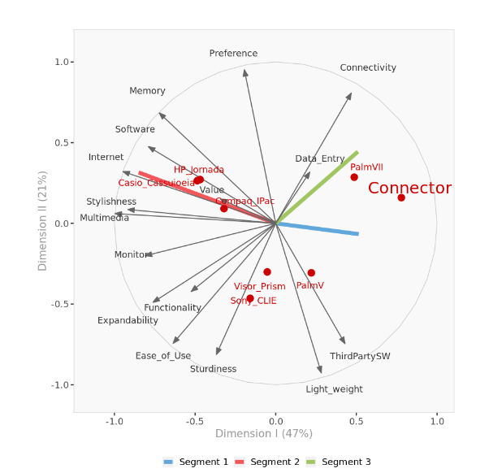

*Figure 12: Segment perceptual Map I-III. Complete perceptual map with objects, attributes and average segment preferences on the first and third dimensions.*

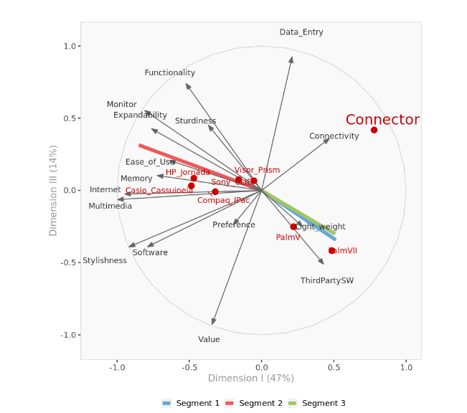

*Figure 13: Segment perceptual Map II-III. Complete perceptual map with objects, attributes and average segment preferences on the second and third dimensions.*

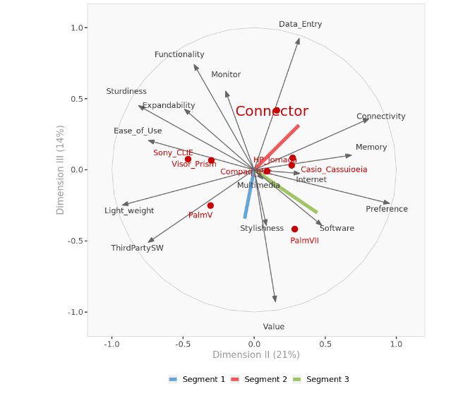

Conector 10L is definitely closest to segment 3 but it seems like people only value it because of the data entry and connectivity, However, preference and value is not far from segment 3 and I think it would be benefit if netlink market the connector as an upgraded cell phone, and could churn more customer based on preference, and value, since it would cost the same but you would get more features.

| **Question 4:** Are there any changes to the features of Connector model L1 (prototype) that should be considered? |
| --- |

**Improve internet access, increasing memory and making it more stylish** Because the majority of the customers surveyed put a lot of value in these attributes. Also the connector is not far from being associated with preference so it would not take as much work to strengthen that association. Also it could think about positioning itself as having internet access, increasing memory and making it more stylish. All three of those attributes will help them position themselves as more attractive to the market because those attributes are important to them. Additionally The Connector should try to increase its perceived value as 2 out of the 3 customer segments demonstrated a moderate affinity for value in PDA’s.

The Conector 10L is definitely closest to segment 3 but it seems like respondents valued it because of the data entry and connectivity features. However, preference and value is not far from segment 3 and I think it would be beneficial if netlink marketed the connector as an upgraded cell phone, and could churn more customers based on preference, and value, since it would cost the same but you would get more features.

| **Question 5:** To work effectively, Connector's voice recognition program requires the user spend a long time training the software to recognize the individual's pronunciation and intonation. Therefore, the feature was demonstrated to the subjects by a Connector product developer using her own trained machine. Comment. |
| --- |

The lengthy user training period needed for Connector's voice recognition algorithm suggests a potential usability issue. Machine learning algorithms are frequently used by voice recognition systems, and for them to perform more accurately, they must be trained on the speech patterns of specific users. Even though this is a frequent approach in the development of such technologies, the prolonged training period could have an influence on the user experience.

**User Investment:** Users must make a substantial investment if they are required to spend a lot of time training the program. Some people who want a quicker and more user-friendly experience might view this as a barrier to access.

**User Commitment:** During the training phase, users' patience and commitment can make or break voice recognition technology. Users who lack the patience or find the process difficult may be deterred from making full use of this function.

**Onboarding Difficulties:** The user experience might not be correctly portrayed by the presentation provided by a Connector product developer using her trained machine. Users might experience issues or differences in their own tone and pronunciation that weren't covered in the presentation.

This demonstration proved to be useful in convincing participants of the Connectors voice recognition system, which can be seen by the devices relatively high Data entry score of 7.7

When compared to its competitors the Connector had significantly higher Data entry value, signifying that consumers were impressed with the devices sophisticated voice recognition software. *Figure 14* below highlights the Connectors score in Data_entry and shows its significance when compared to the other devices in the sample. Although an arduous process, the tech demonstration was a useful tool for survey participants, further demonstrations should be used as marketing opportunities.

*Figure 14: Effectiveness of Demonstration on Data_Entry score.*

|  | **Connector** | **Mean** | **Stdev** | **Z** | **p value** |
| --- | --- | --- | --- | --- | --- |
| **Data_Entry** | 7.7 | 5.388 | 1.0218 | 2.262673713 | 0.01182790521 |

| **Question 6:** What ongoing research program would you recommend to Netlink to improve its evaluation of its segmentation of the market and positioning of its products? |
| --- |

There are several possible market research opportunities that Nelink could partake in. One such opportunity would be to conduct a similar analysis of customer preferences using a reduced set of attributes and an increased set of competitors. Many of the attributes appeared to not be very useful in categorizing or determining the overall preference for each device, for example categories like expandability and memory appeared to be correlated and therefore could be collapsed into a single more useful attribute. Additionally a greater sample of devices could be sampled to better understand the competitive landscape for the PDA market. As previously mentioned further research could study the key demographics of the customer segments. This demographics data can be used to better tailor features, designs, and marketing strategies. Also The research could include more information about customer demographic. We had little customer demographics information which is important to have when creating a STP strategy. I would also suggest that they do conjoint analysis to determine what product feature customers are most interested in, and what value those feature hold in the eyes of the consumers. From there they could make a second round of prototypes based on the conjoint analysis, and STP Analysis.

| **Question 7:** Summarize the advantages and limitations of the software provided for this application. |
| --- |

**Advantages:**

* **Automated calculations:** Long and rigorous calculations that would take significant time to conduct by hand can be automated to run nearly instantaneously.
* **Limited technical knowledge required:** the prepackaged analysis requires little to no technical knowledge of the underlying methodologies to understand and use the software.
* **Minimal computational power required:** Runs in a web browser, no proprietary software required
* **Automated report generation:** The software returns an automated report which covers most needs in analysis of positioning. Visualizations and brief commentary is included
* **3 Dimensional Graphs**: The interactive 3d mapping was a helpful tool. It enables the user to look at each segment in every dimension, which is helpful because the 2D perceptual maps are harder to interpret with the data in three dimensions. This Made it much easier to define the segments.

**Limitations:**

* **Limits to size of data sets:** data sets are limited to dozens of records and attributes, making it far too small for larger more complex data sets.
* **Minimal customization in reports:**  As reports are templated, there is little in the way of customization of the reports sections visuals or commentary.
* **Must Create a market research** survey, and aggregate the data before one could use the software.
* **Lack of customization in analysis:** The software provides minimal customization for more complex analysis. For instance a cumulative variance of 80% is locked for choosing the number of relevant principle components. Many could find this limitation to be detrimental to their analysis and experience with the software.

**CONCLUSION AND MANAGERIAL INSIGHTS:**

Netlinks Connector failed to deliver on mainstream appeal but could potentially target a specific segment of customers who value Connectivity and Data entry capabilities. Going forward Netlink should align on which direction it wants to take the Connector in.

If Netlink wants to boost the Connectors mainstream appeal, they should work on some of its lowest scoring attributes that are associated with segments 1 and 2 which is where most of the competition is competing in. Many of the competitors in the market are perceived as better multimedia players and this does better with segment 1, Netlink could try and win over these customers by offering better multimedia capabilities.

However if Netlink wanted to focus more on a specific niche segment then they could differentiate the Connector from other competitors and try to increase the perception of value, data entry, preference and 3rd party software where there is little competition. This approach may take less work to increase the scores of these attributes compared to approach 1 because the Connector is not weak in these attributes but it is not strong either. Netlink should research if it should position the product as a upgraded cell phone, not a substitute, as few competitors seem to use this line within the PDA market.